**Cookies and Sessions** are both used to **store data on the server and client sides to maintain state and track user interactions** across a web application. Here are the key differences and use cases for each:

Cookies

Client-Side Storage:

Cookies are stored on the user's browser.

They are sent with every HTTP request to the server.

Lifetime:

Cookies can have an expiration date set, after which they are deleted.

They can be persistent (lasting until the expiration date) or session-based (deleted when the browser is closed).

Size Limit:

Each cookie can hold up to 4 KB of data.

Browsers typically limit the number of cookies per domain (around 20-50).

Security:

Cookies can be secured using attributes like HttpOnly (not accessible via JavaScript), Secure (sent only over HTTPS), and SameSite (control cross-site request sharing).

Use Cases:

Remembering user preferences and settings.

Tracking user sessions in combination with server-side session storage.

Storing authentication tokens (although this can pose security risks).

Sessions

Server-Side Storage:

Session data is stored on the server.

The server assigns a unique session ID to each session, which is usually stored in a cookie on the client side.

Lifetime:

Sessions are generally short-lived and expire after a period of inactivity or when the user logs out.

Session expiration can be managed by the server.

Size Limit:

The amount of data stored in a session is limited only by the server's capacity.

Sessions can store complex data structures and large amounts of data.

Security:

Sessions are more secure than cookies because the data is stored on the server.

Only the session ID is stored on the client, reducing the risk of data exposure.

Use Cases:

Storing user-specific data such as login status, user preferences, and shopping cart contents.

Managing user authentication and authorization.

Tracking user activity within a session.

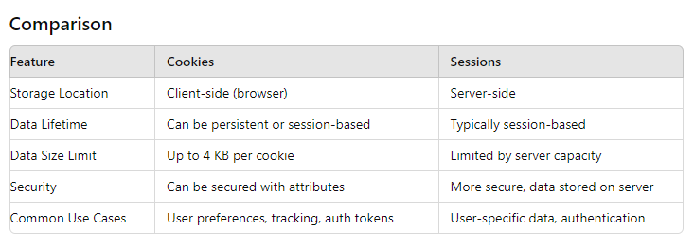

**Best Practices**

**Cookies**: Use for lightweight data that needs to persist between sessions or across different sessions. Ensure proper security measures like HttpOnly, Secure, and SameSite attributes are used.

**Sessions**: Use for sensitive data and when storing larger or complex data structures. Ensure session data is managed securely on the server and that session IDs are protected.

In most web applications, a combination of both cookies and sessions is used to balance security, performance, and user experience.